Indicate the answer choice that best completes the statement or answers the question.

1. In Canada, one worker can produce 10 tons of steel per day or 20 tons of chemicals per day. In the United States, one worker can produce 5 tons of steel per day or 15 tons of chemicals per day. The United States has the absolute advantage in the production of:
 | a. | steel.
 | b. | chemicals.
 | c. | neither steel nor chemicals.
 | d. | both steel and chemicals.  ​

2. Figure: Home and Foreign Autarky (No trade) Equilibria
​
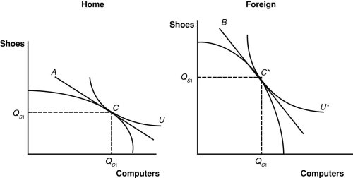
​
According to the shapes of the two PPFs, which nation has a comparative advantage in the production of computers?
 | a. | Home
 | b. | Foreign
 | c. | neither Home nor Foreign
 | d. | both Home and Foreign  ​

3. In the two-sector (manufacturing and agriculture) specific-factors model, suppose that the home country exports the agricultural output. What happens to the amount of capital used in agricultural production when trade occurs?
 | a. | It falls.
 | b. | It rises.
 | c. | It does not change.
 | d. | It first falls, then rises.

4. Figure: Home and Foreign Autarky (No trade) Equilibria
​

​
Which line in the graph represents Foreign's relative price of computers in terms of shoes?
 | a. | A
 | b. | B
 | c. | U
 | d. | U*  ​

5. If the relative price of one product rises and labor is mobile, then in the short run:
 | a. | labor will move to the sector where the output price increase happened.
 | b. | labor will move to the sector where the output price did not change.
 | c. | labor will increase in both sectors.
 | d. | labor will remain unchanged.

6. Which of the following is NOT an effect of an import tariff?
 | a. | It increases producer surplus by raising the market price and allowing more production.
 | b. | It raises government revenue.
 | c. | It reduces consumer surplus by raising the market price.
 | d. | It improves efficiency in the economy overall because it saves high-paying jobs.

7. Which of the following statements describes what the Ricardian model predicts as a nation improves its technology and productivity?
 | a. | Its standard of living will rise.
 | b. | Wages of its workers will fall.
 | c. | It will lose its absolute advantage.
 | d. | It will lose its comparative advantage.

8. What is a difference between a tariff imposed by a large country and a tariff imposed by a small country?
 | a. | A tariff imposed by a large country has no deadweight consumption and production losses.
 | b. | A tariff imposed by a large country has a terms-of-trade effect.
 | c. | A tariff imposed by a small country has a terms-of-trade effect.
 | d. | A tariff imposed by a large country has no deadweight consumption loss.

9. The Ricardian model (with constant opportunity costs) predicts that a nation will ______________.
 | a. | have a comparative disadvantage in the production of the good it exports
 | b. | develop shortages in the good it exports
 | c. | lower the cost of production in the good it exports
 | d. | specialize completely

10. In the two-sector (manufacturing and agriculture) specific-factors model, suppose that a country has a comparative advantage in manufacturing output. Will workers be better or worse off following the opening of trade with other countries?
 | a. | Workers will be better off because the nominal wage will increase.
 | b. | Workers will be better off because both nominal and real wages will increase.
 | c. | Workers may be better off or worse off because the real wage in terms of the agricultural good will rise and the real wage in terms of the manufactured good will fall.
 | d. | Workers may be better off or worse off because the real wage in terms of the agricultural good will fall and the real wage in terms of the manufactured good will rise.

11. (Figure: Canada's Production and Consumption)
​
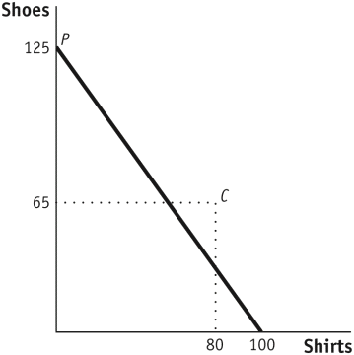
The graph shows Canada's international trading pattern. With free trade, how many shoes and shirts does Canada import and/or export?
 | a. | Canada imports 65 shoes and exports 80 shirts.
 | b. | Canada imports 60 shoes and exports 20 shirts.
 | c. | Canada exports 65 shoes and imports 20 shirts.
 | d. | Canada exports 60 shoes and imports 80 shirts.  ​

12. The argument that trade generates gains for all workers may NOT be true because:
 | a. | a more realistic assumption includes capital and land as specific factors of production and recognizes that trade will generate gains for some factors and losses for others.
 | b. | greedy corporations exploit workers.
 | c. | technology gains are concentrated among low-skilled workers.
 | d. | some workers lack skills and training and cannot find jobs.

13. Figure: A Country's Before-and-After Trade Equilibria

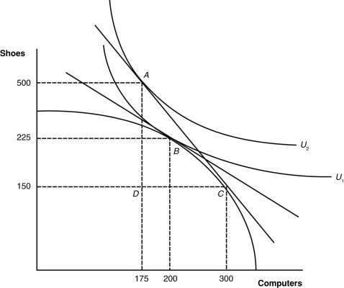

What is the equilibrium post-trade point of production of this nation?
 | a. | A
 | b. | B
 | c. | C
 | d. | D

14. The conclusion that a labor-abundant country exports the good that uses labor intensively in production and a capital-abundant country exports the good that uses capital intensively in production is known as:
 | a. | factor intensity reversal.
 | b. | the Heckscher–Ohlin theorem.
 | c. | Ricardian comparative advantage.
 | d. | the Stolper–Samuelson theorem.

15. Table: Production and Prices in Two Industries

Marginal Product of Labor in Agriculture (MPLa) | Marginal Product of Labor in Manufacturing (MPLm) | Price of Agricultural Good (Pa) | Price of Manufactured Good (Pm)
5 | 3 | $10 | $10

Using the information from the table, we can expect which of the following to happen in the economy?
 | a. | Labor will migrate from the agriculture to the manufacturing sector.
 | b. | Labor will migrate from the manufacturing to the agriculture sector.
 | c. | The marginal product of labor in the agriculture sector will increase.
 | d. | The marginal product of labor in the manufacturing sector will decrease.

16. The increase in total utility derived from trading products is called:
 | a. | trade patterns.
 | b. | gains from trade.
 | c. | comparative advantage.
 | d. | labor productivity.

17. Table: Output in the Canada and China
​
 | Canadian Output per Worker | Chinese Output per Worker
Apparel | $100,000 | $10,000
Wheat | $200,000 | $5,000
​
Which product(s) will Canada export to China?
 | a. | wheat
 | b. | apparel
 | c. | neither wheat nor apparel
 | d. | both wheat and apparel  ​

18. Ricardo’s approach to trade was a reaction and a repudiation of which school of thought?
 | a. | mercantilism
 | b. | classical economics
 | c. | comparative advantage
 | d. | absolute advantage

19. Under free trade and comparative advantage, the home country:
 | a. | will see only benefits for its resources.
 | b. | will see only losses for its resources.
 | c. | will see winners and losers within its economy.
 | d. | will be convinced that trade is not beneficial.

20. In a two-sector (manufacturing and agriculture) specific-factors model:
 | a. | land is specific to the manufacturing sector.
 | b. | labor is specific to the manufacturing sector.
 | c. | capital is specific to the manufacturing sector.
 | d. | labor and capital are specific to the manufacturing sector.

21. Consumer surplus is:
 | a. | the difference between the price of a product and consumers' valuation of the last unit of the product purchased.
 | b. | the difference between the price of a product and what consumers were willing to pay for the product.
 | c. | the difference between the discounted price of a product and its retail price.
 | d. | the difference between the price paid by consumers and the price required of producers.

22. Assume that strawberries are labor-intensive and cell phones are capital-intensive. A capital-abundant country’s PPF will be:
 | a. | skewed toward strawberries.
 | b. | skewed toward cell phones.
 | c. | a straight line.
 | d. | upward-sloping in strawberry production.

23. Malaysia is relatively abundant in labor, whereas Canada is relatively abundant in capital. In both countries, shirt production is relatively more labor-intensive than computer production. According to the Heckscher–Ohlin model, Malaysia will have a(n) ________ advantage in the production of __________.
 | a. | absolute; shirts and computers
 | b. | absolute; computers
 | c. | comparative; shirts
 | d. | comparative; computers

24. (Figure: Home Production and Consumption)

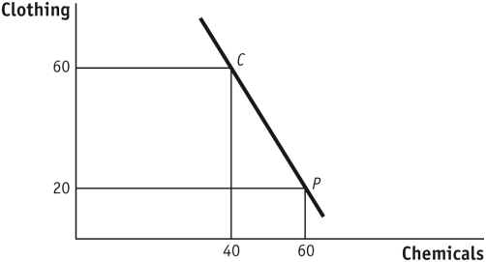

The figure gives Home's international trading pattern. Point P is production with trade and point C is consumption with trade. How many units of which product does Home export, and how many units of which product does it import?
 | a. | Home exports 60 units of chemicals and imports 20 units of clothing.
 | b. | Home exports 40 units of chemicals and imports 60 units of clothing.
 | c. | Home exports 40 units of clothing and imports 20 units of chemicals.
 | d. | Home exports 20 units of chemicals and imports 40 units of clothing.

25. Home has a comparative advantage in wheat, and Foreign has a comparative advantage in cloth. Once trade occurs, Home produces 1,000 bushels of wheat, and Foreign produces 1,000 yards of cloth. The following table shows the amount of wheat that Home is willing to supply and Foreign is willing to buy at various international prices.

International Price | Home’s Wheat Exports | Foreign’s Wheat Imports
1 yard/1 bushel | 100 bushels | 900 bushels
2 yards/1 bushel | 200 bushels | 800 bushels
3 yards/1 bushel | 300 bushels | 700 bushels
4 yards/1 bushel | 400 bushels | 600 bushels
5 yards/1 bushel | 500 bushels | 500 bushels
6 yards/1 bushel | 600 bushels | 400 bushels
7 yards/1 bushel | 700 bushels | 300 bushels
8 yards/1 bushel | 800 bushels | 200 bushels
9 yards/1 bushel | 900 bushels | 100 bushels

What is the international price of wheat?
 | a. | 1 yard/bushel
 | b. | 3 yards/bushel
 | c. | 5 yards/bushel
 | d. | 7 yards/bushel

26. Suppose that land is specific to agriculture, capital is specific to manufacturing, and labor is mobile between sectors. According to the specific-factors model, if this country begins importing manufactured goods, which factor will experience the highest unemployment?
 | a. | labor
 | b. | capital
 | c. | land
 | d. | No factors will experience unemployment.

27. As a nation begins to export, its own relative price of exported goods will ______, and as it imports other goods, the relative price of those will ______ , thus ___________ its standard of living.
 | a. | fall; rise; lowering
 | b. | rise; fall; lowering
 | c. | rise; fall; raising
 | d. | fall; rise; raising

28. (Figure: Home Production and Consumption)



The figure gives Home's international trading pattern. Point P is production with trade, and point C is consumption with trade. What is the international price of chemicals according to the figure?
 | a. | 1/2 unit of clothing per unit of chemicals
 | b. | 1 unit of clothing per unit of chemicals
 | c. | 2 units of clothing per unit of chemicals
 | d. | 3 units of clothing per unit of chemicals

29. Table: Sales and Payments

Manufacturing sales revenue = $1,000
Total wages paid to labor in manufacturing = $500
Total wages paid to labor in agriculture = $500
Total payments to land = $500

What is the total revenue (price · quantity) of the agricultural sector?
 | a. | $400
 | b. | $500
 | c. | $600
 | d. | $1,000

30. The Heckscher–Ohlin model assumes that there are two countries, each of which produces two goods (say, manufactures and agriculture) using labor and capital. Which of the following is an additional assumption of the Heckscher–Ohlin model?
 | a. | The ratio of the quantity of labor to the quantity of capital is different for each nation, resulting in different “endowments” of capital and labor.
 | b. | One nation has larger quantities of both capital and labor than the other country.
 | c. | Capital is a specific resource in producing manufactured goods, and labor is a specific resource in producing agricultural goods in each country.
 | d. | Labor and capital can move between countries.

31. According to Ricardo:
 | a. | all countries gain from trade if they export goods for which they have an absolute advantage.
 | b. | one country gain from trade only at the expense of another country.
 | c. | all countries gain from trade if they export goods for which they have a comparative advantage.
 | d. | all countries lose from international trade.

32. In the United States, one worker can produce 10 tons of steel per day or 20 tons of chemicals per day. In the United Kingdom, one worker can produce 5 tons of steel per day or 15 tons of chemicals per day. If trade occurs between the United States and the United Kingdom, American firms should specialize in producing:
 | a. | steel.
 | b. | chemicals.
 | c. | neither steel nor chemicals.
 | d. | both steel and chemicals.

33. The most favored nation clause requires that a WTO member:
 | a. | reduces a tariff on imports from one WTO trading partner and applies the lower tariff to imports from all other WTO members.
 | b. | reduces a tariff on imports from one WTO trading partner and applies the lower tariff to imports from all other countries.
 | c. | increases a tariff on imports from one WTO trading partner and raises the tariff on imports from most other WTO members.
 | d. | increases a tariff on imports from one WTO trading partner and raises the tariff on imports from all other countries.

34. Mercantilists believed that:
 | a. | exporting goods will leave fewer goods for the local economy.
 | b. | importing goods is beneficial for the economy.
 | c. | exports and imports are both bad for the economy.
 | d. | exports are good and imports are bad for the economy.

35. How many units will a country import if S = P represents its home supply curve, D = 100 – P represents its home demand curve, and the world price is $25?
 | a. | 25
 | b. | 50
 | c. | 75
 | d. | 100

36. Table: Revenues and Costs for Two Industries

Manufacturing | Agriculture
Sales revenue = PM · QM = $100 | Sales revenue = PA · QA = $100
Payments to labor = W · LM = $70 | Payments to labor = W · LA = $60
Payments to capital = RK · K = $30 | Payments to capital = RT · T = $40

Suppose that the table gives payments to labor, land, and capital in the manufacturing and agriculture sectors. Now, suppose that the price of manufactured goods increases by 10% (PM) and wages increase by 5%; then the rental rate on land will:
 | a. | increase by 7.5%.
 | b. | decrease by 5%.
 | c. | decrease by 7.5%.
 | d. | not change.

37. If a country finds its comparative advantage in computer production, which is capital-intensive, what will happen to the rental rate on capital when trade occurs?
 | a. | It will decrease.
 | b. | It will stay the same.
 | c. | It will increase.
 | d. | Not enough information is given to answer this question.

38. Consider two products: automobiles and shoes. If shoes are labor-intensive and automobiles are capital-intensive, what will happen under the Heckscher–Ohlin model?
 | a. | The labor-abundant country will export automobiles.
 | b. | The capital-abundant country will export shoes.
 | c. | The labor-abundant country will import shoes.
 | d. | The capital-abundant country will import shoes.

39. Poland requires 4 hours of labor to produce 1 ton of coal and 1 hour of labor to produce a bushel of wheat. The Czech Republic requires 6 hours of labor to produce 1 ton of coal and 1 hour of labor to produce a bushel of wheat. In Poland, what is the marginal product of labor in coal production?
 | a. | 0.25 ton per hour
 | b. | 0.4 ton per hour
 | c. | 2.5 tons per hour
 | d. | 4 tons per hour

40. Figure: Consumer Surplus

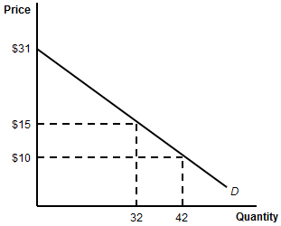

By how much will consumer surplus increase if the price of the product decreases to $10?
 | a. | $441
 | b. | $256
 | c. | $185
 | d. | $160

Answer Key
1. c

2. a

3. c

4. b

5. a

6. d

7. a

8. b

9. d

10. c

11. d

12. a

13. c

14. b

15. b

16. b

17. a

18. a

19. c

20. c

21. b

22. b

23. c

24. d

25. c

26. d

27. c

28. c

29. d

30. a

31. c

32. a

33. a

34. d

35. b

36. c

37. c

38. d

39. a

40. c

